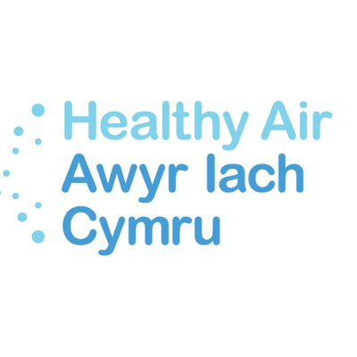
Healthy Air Cymru Press Release
Embargoed 11:00am Wednesday 15th January 2020
(or in accordance with the Council’s own release time)

Healthy Air Cymru statement on Cardiff Council’s Transport White Paper.

Haf Elgar, Vice Chair of Healthy Air Cymru said; “It’s promising to see a road user charge being put forward in today’s transport white paper from Cardiff Council. This was a crucial element we felt was missing in the clean air plan and we are relieved to see that a long-term commitment to improving air quality features in the council’s transport vision.”

“This is about reducing emissions to combat climate change, improving air quality to protect our health and creating a cleaner, safer and more attractive city in which to live and work. We must see a change in the way we think about travel and we can only do that by introducing bold interventions that will help people make the best choices for them.”

“It’s also promising to see that the city-wide road user charge will be supported by improved public transport and active travel infrastructure, which will play an integral role in making the transition to sustainable methods of travel much more affordable and achievable.”

“It would be great to see a ban on diesel introduced to the timeline of actions, to ensure we really are doing all we can to achieve the cleanest air possible. When our health, our environment and our way of life is on the line, everyone has a part to play in creating the change we need to see.”

End

For further enquiries please contact huw.cook@blf.org.uk, 07511900483.

Notes:
Healthy Air Cymru is a coalition of third sector, academic and legal organisations campaigning for better air quality in Wales. We run the CPG on A New Clean Air Act and continue to lobby Welsh Government and Local Authorities to ensure they introduce the most sustainable and effective solutions to Wale’s toxic air crisis.
Healthy Air Cymru Website: http://healthyair.cymru/
Healthy Air Cymru Twitter: @Healthy Air Cymru

